How to use netmapping
i recommend you to use the v2 lite version
it ươuld takes you some seconds to open the program
to use,get yourself a link (example : https://solarzone1010.github.io/)
This is the gui when you open v2 lite version
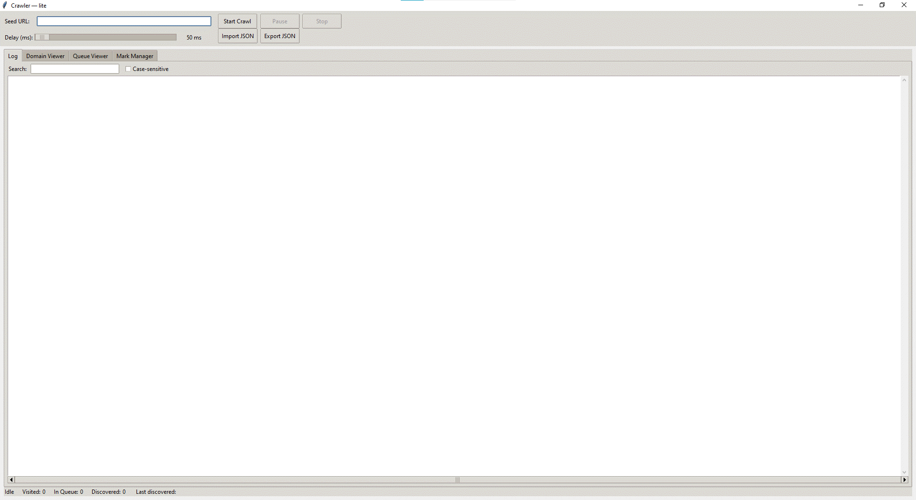
In “seed ulr” textbox (it is above the navigation bar) , paste you url and press start crawl
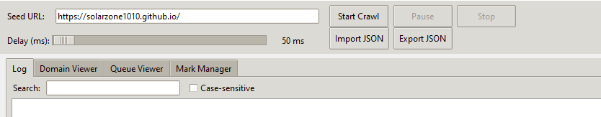
If the link is valid,you will see these logs,this is mean the programe now is searching
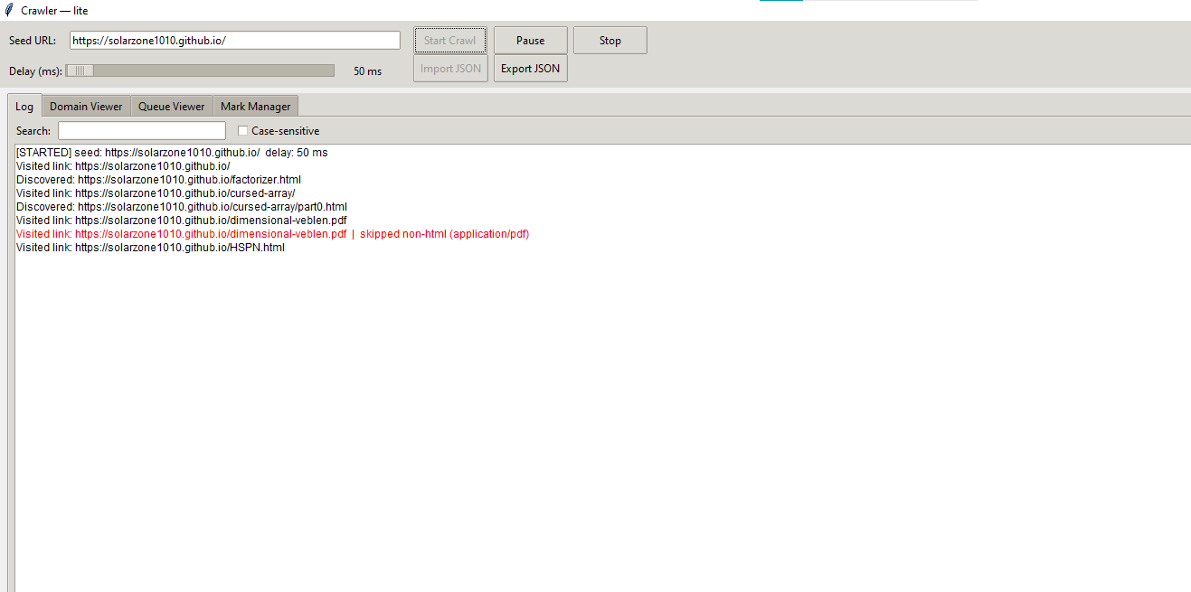

Furthermore,there are many others feature!
1.Domain viewer
on the navigations,you can switch between tabs
this is the main feature of this program,this allow you to visualize the website domains
The visualizer is not update automatically,so press refresh!
this allow you to
+ search links
+ Mark links
+ manual visit links (programe will put this on top) right click links
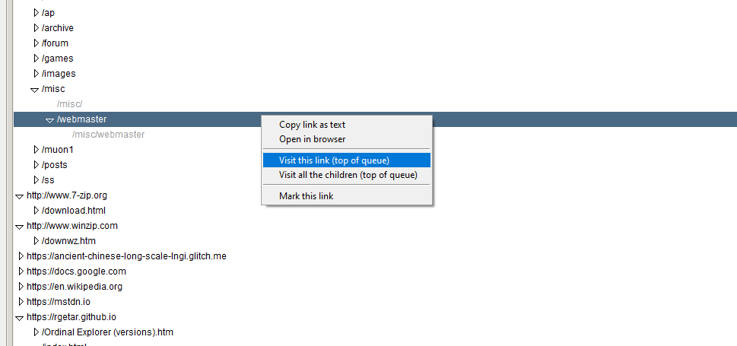
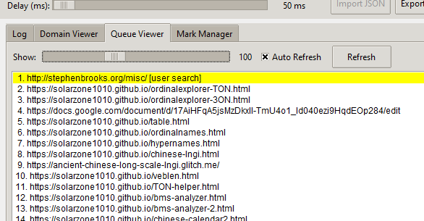
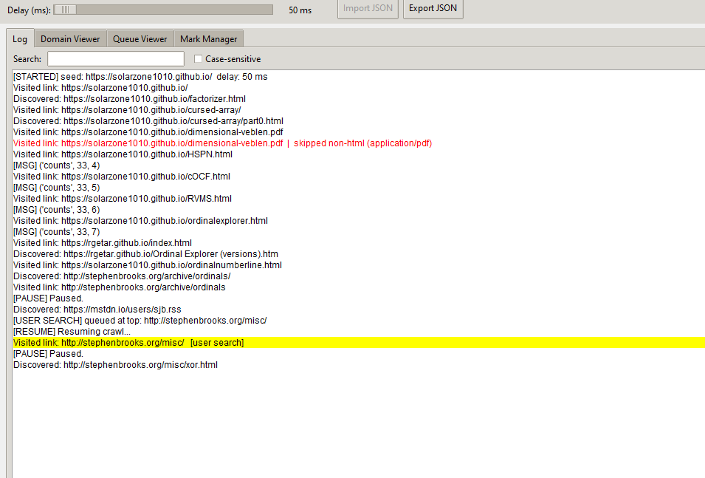

2. Queue viewer not much, this allow you so see upcoming link that the programe will visit
yellow highlighted links are your manual search! 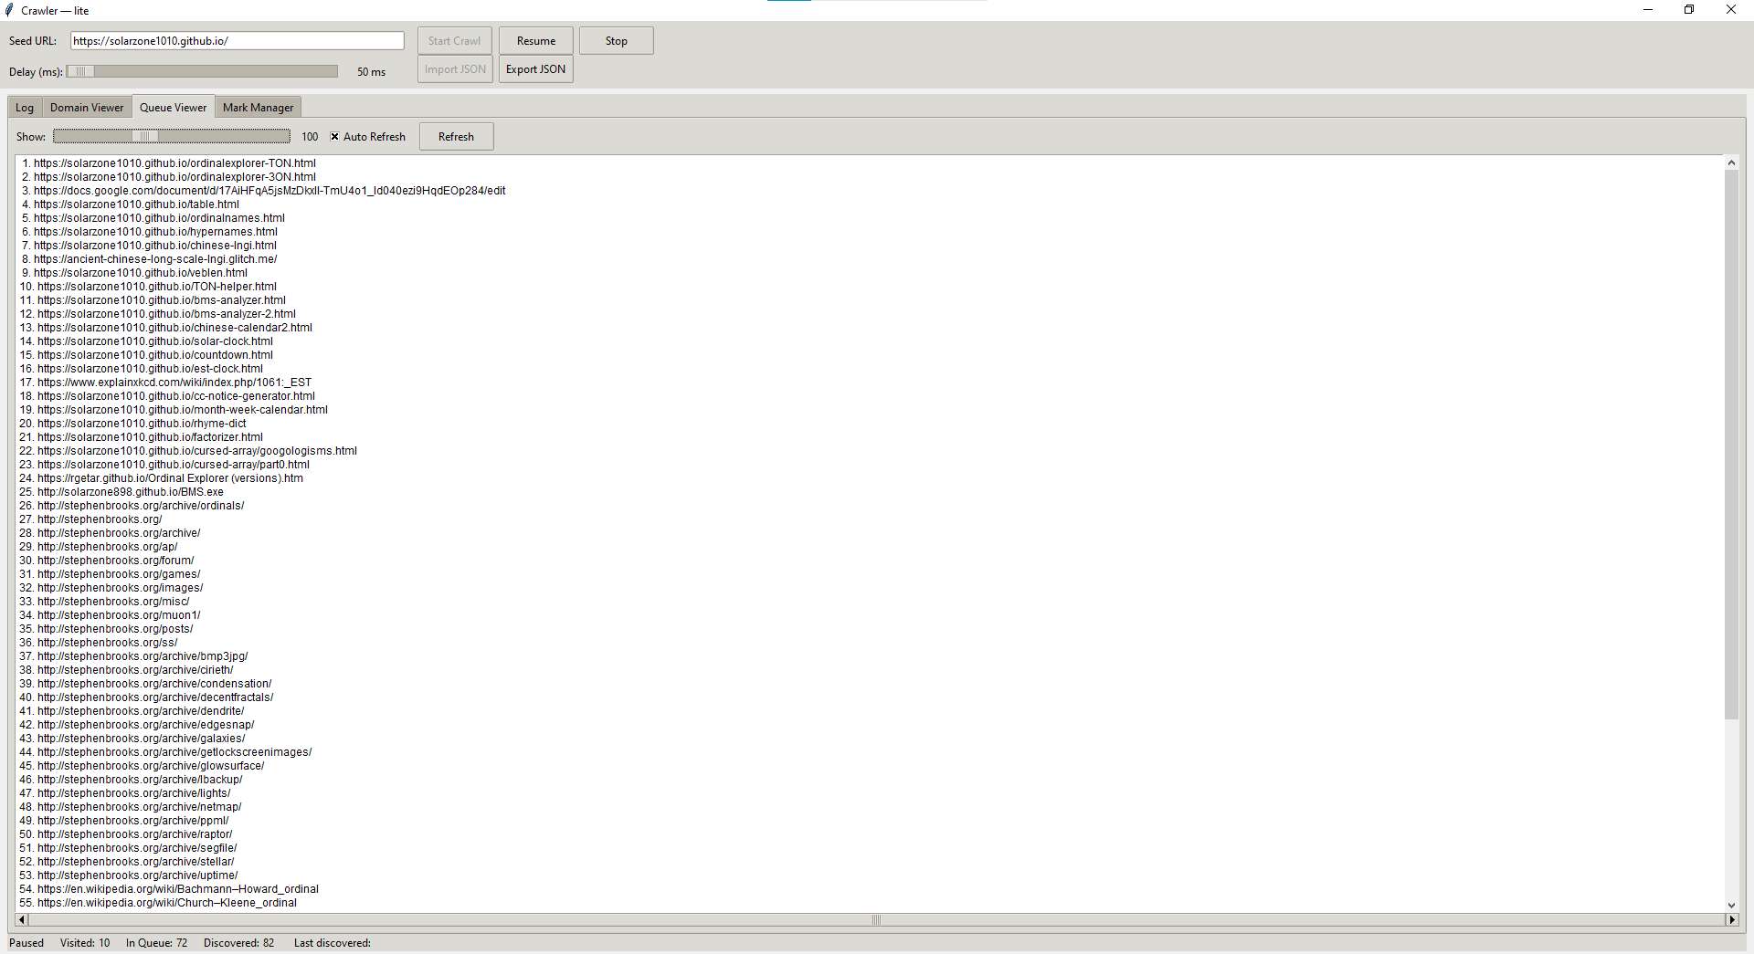

3.Mark manager
where you can manage your marked links!
right clicks on link
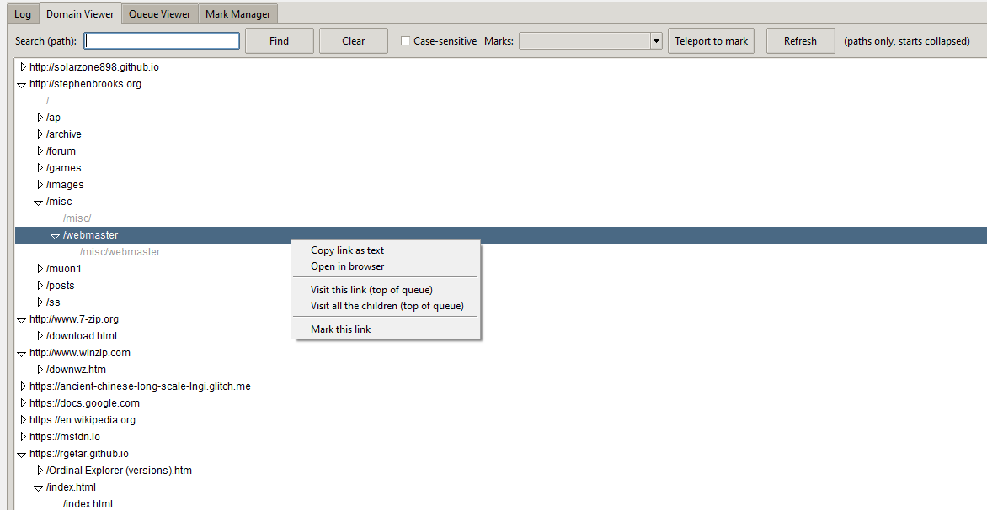
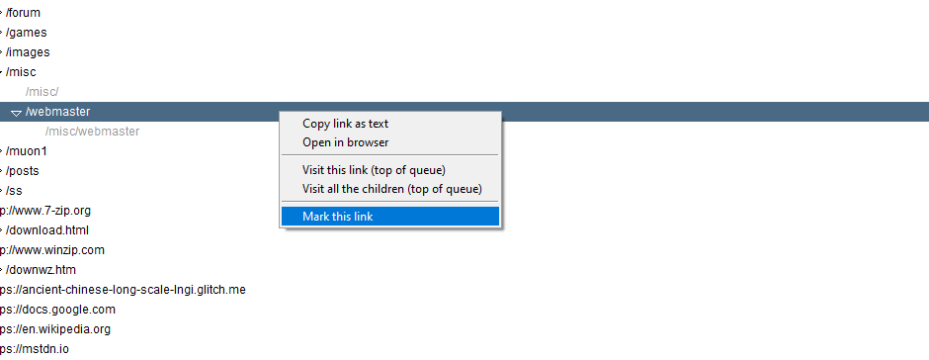
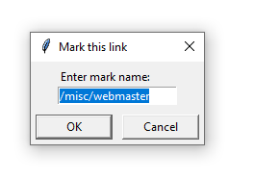
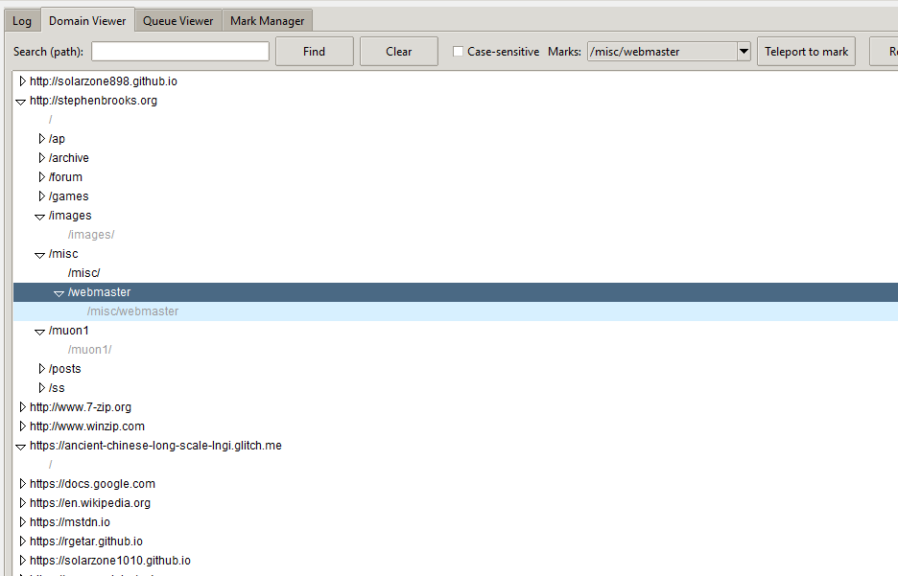
blue highlighted = marked
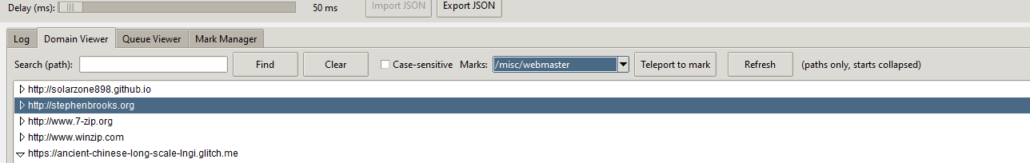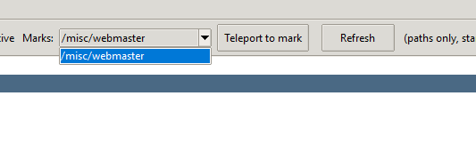
Press teleport to mark to teleport to marked links
to chage name/delet mark
open mark manager
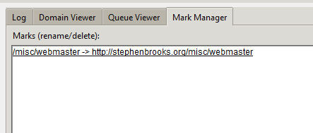
Press the link
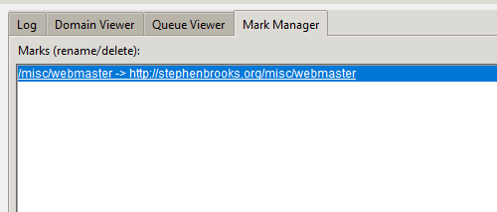
Look to the left-bottom corner
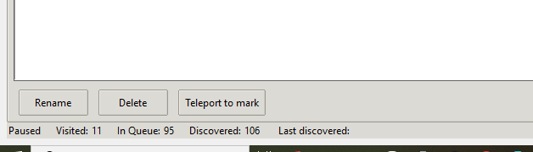
press rename 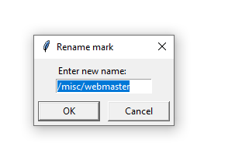
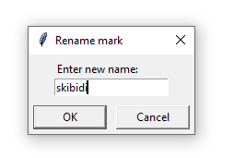
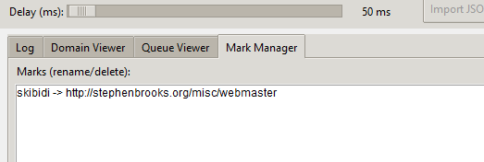
skibidi now lead to http://stephenbrooks.org/misc/webmaster

press Delet
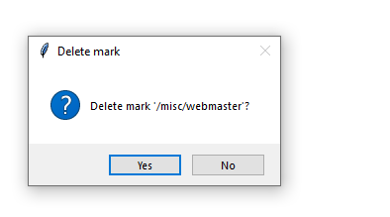
Press yes,and the link gone
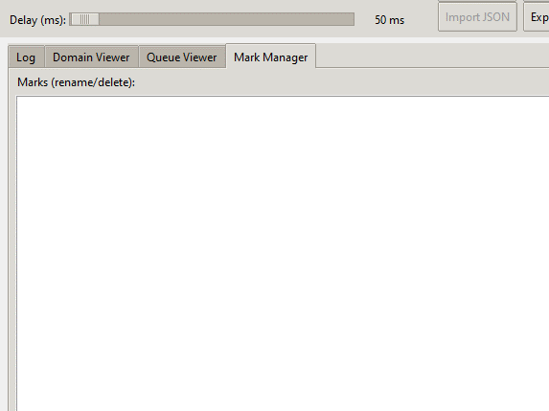
There are many many feauture like
+case sensitive search (lower,upper case)
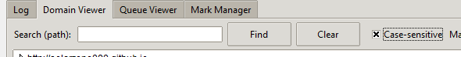
+save/load/pause/stop/interval
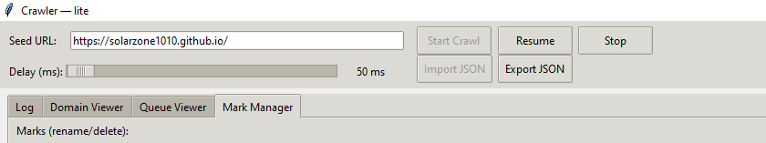
+advanced highlighter system
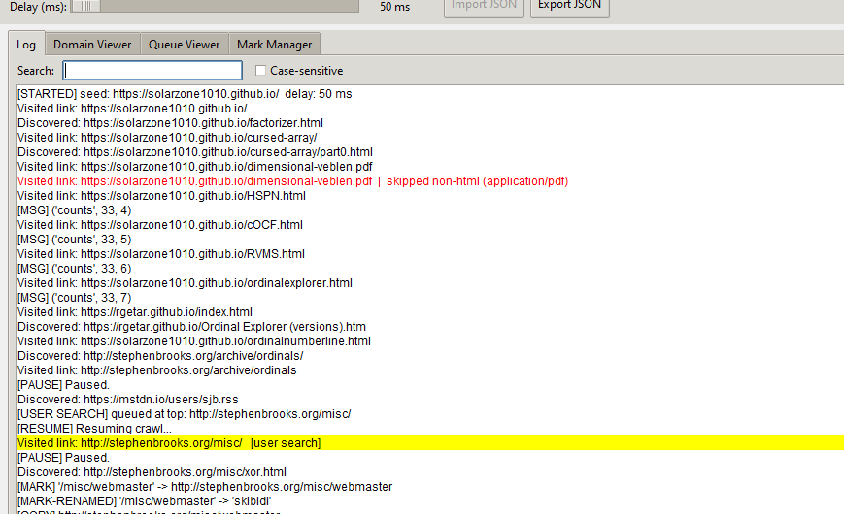
+… ect
ENJOY!

